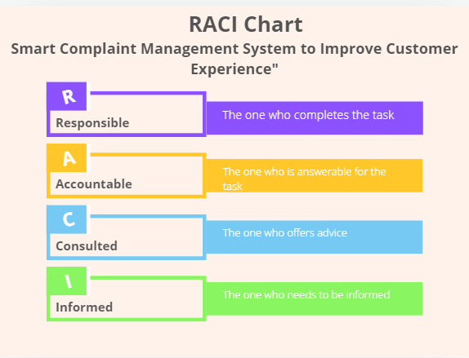

|  |  |  |  |  |  |  |  |
| --- | --- | --- | --- | --- | --- | --- | --- |
| Task | Project Manager | IT Manager | Developers | Technical Support Team | Training Team | Consultants | Customers |
| Analyze current complaint process | R | A |  | C |  | I | I |
| Design the system | A | R | C |  |  | C | I |
| Develop the system | A | C | R |  |  | I |  |
| Test the system | A | R | C | I |  | I |  |
| Train employees | I | C |  | I | R | A |  |
| Implement the system | A | R |  | C |  | I |  |
| Monitor performance & improvements | R | C |  | I |  | A | I |